***k-Nearest Neighbors (KNN)***

K-nearest neighbours algorithm is a **Classification** algorithm. In order to classify a target data point it simply looks at its nearest neighbours and then decides the class of the point on the basis of the class to which majority of the nearby points belong to.

In KNN we can specify the value of K which denoted how many nearest points we should consider before deciding upon the class of the target point.

**In its simple version KNN considers its single nearest neighbour, that is, k=1.**

**For example:**

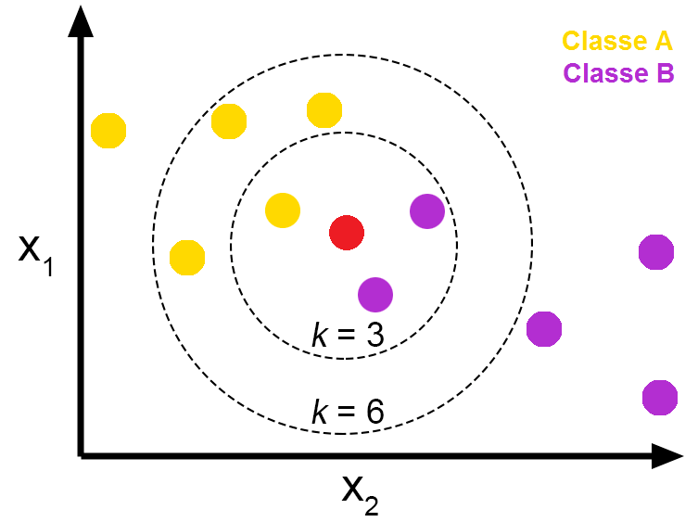

In the above example **when we set k=3** we see the **target point** (red) looks to 3 nearest points and finds out 1 point belongs to **Class A** (yellow) and 2 belong to **Class B** (purple). Class B being the majority the target point belongs to Class B.

**For k=6** we see that 4 belong to Class A and 2 to Class B. Hence the resultant class will be Class A.

***Advantages:***

* Easy to understand and fast to implement
* Often gives a good performance without a lot of adjustments.

***Disadvantages:***

* Very slow to make a prediction.
* Bad when you have too many features.
* Not good for a very large dataset.
* A bit tough to decide the correct value for K ( **choosing a very low value makes a very complex model and choosing a very high value makes a too generalized model** which in not good either.)